|  |
| --- |
| JPEG-Sirius's Logo.jpg |
| The Specification |
| Vatfairfoot |
|  |
| **Michael Lallemand** |
| **6/17/2013** |



Functional Specifications

Table of Contents

[To update the table of contents, right click the message below and select Update Field (F9 on PC, ⌥⌘U on Mac).]

1. Pages 3

1.1. Page Tree 3

1.2. Tech info 4

1.3. Home 7

1.3.1. User Interface 7

1.3.2. Widget Table 8

1.4. PRODUITS 9

1.5. Tous les produits 9

1.6. Fiche produits 10

1.6.1. User Interface 10

1.7. News 11

1.7.1. User Interface 11

1.7.2. Widget Table 12

1.8. Gallery 13

1.9. Photos 13

1.9.1. User Interface 14

1.10. Videos 15

1.10.1. User Interface 16

1.11. Amis (friends) 17

1.11.1. User Interface 17

1.11.2. Widget Table 18

1.12. BLOG 19

1.13. STORY 19

1.14. Notre histoire 19

1.15. Nos engagements 19

1.16. Nos actions 19

1.17. CONTACT 19

1.18. DOWNLOAD 19

1. Pages
   1. Page Tree

Tech info  
Home  
 PRODUITS  
 Tous les produits  
 Fiche produits  
 News  
 Gallery  
 Photos  
 Videos  
 Amis (friends)  
 BLOG  
 STORY  
 Notre histoire  
 Nos engagements  
 Nos actions  
 CONTACT  
 DOWNLOAD

* 1. Tech info

PROJECT: Vatfairfoot eCommerce

**CMS**: Prestashop

**Thème**: 01PREMIUM:

http://addons.prestashop.com/demo/FO5387.html

**BLOG MODULE**

http://addons.prestashop.com/fr/content-management/2500-blog-prestablog-posts-categories-comments-products.html

**NEWSLETTER**

Please advise a suitable newsletter module.

3 languages:

FR

EN

SP

**SITEMAP**:

HOME

PRODUITS

HOMMES

• Tous

• T-Shirt

• Casquette

• Bob

• Chaussures

• Tongs

FEMMES

• Tous

• T-Shirt

• Casquette

• Bob

• Chaussures

• Tongs

ACCESSOIRES

• Porte-clefs

• Ceinture

• Sac

GALLERY

Photos

Videos

AMIS

BLOG

STORY

Notre histoire

Nos engagements

Nos actions

DOWNLOAD

Tailles

Pointures

App. souris

NOTRE ACTUALITE

News 1

News 2

FOOTER

MON COMPTE

Mes commandes

Mes avoirs

Mes adresses

Mes informations personnelles

Mes produits favoris

Sign out

CATÉGORIES

HOMMES

FEMMES

ACCESSOIRES

INFORMATION

Promotions

Nouveaux produits

Meilleures ventes

Nos magasins

Contactez-nous

Terms and conditions of use

À propos

Plan du site

CONTACTEZ-NOUS

NOUS SUIVRE

Facebook

Twitter

Google+

Pinterest

NEWSLETTER

**CONTENT AND GRAPHICAL ELEMENTS**

Graphist, photograph, video all content will be provided by Vatfairfoot

* 1. Home

- The pointer of the mouse is changed to a feet like the logo.

<http://www.htmlgoodies.com/beyond/css/create-custom-cursors-with-javascript-and-css3.html#fbid=S4Px4LNHjYO>

* + 1. User Interface

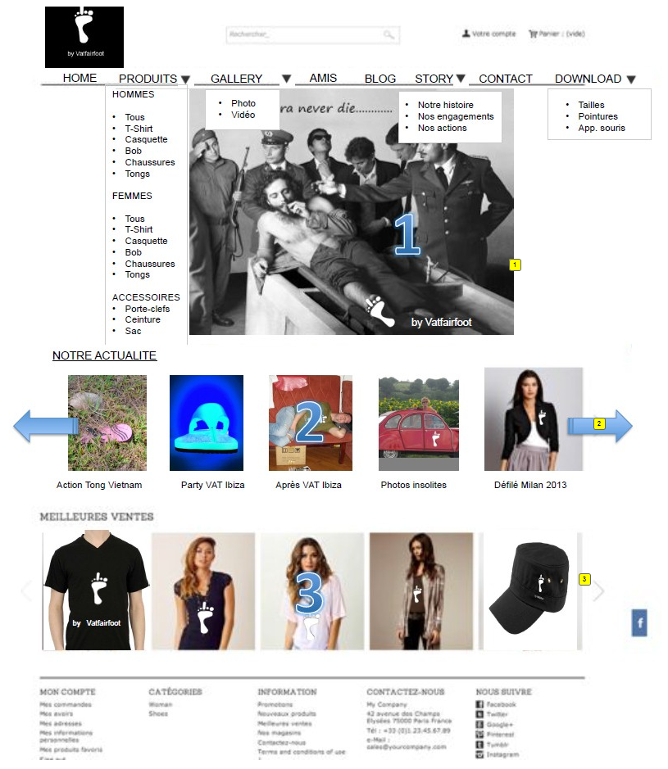

* + 1. Widget Table

|  |  |  |
| --- | --- | --- |
| Footnote | Label | Description |
| 1 | Main slider | Slider contains 5 photos slides every 5 seconds |
| 2 | News slider | Slider contains 5 photos visible (latest 5 news). slides if user clicks on the arrow. The slider contains max 20 news. The news on the slider is composed of 1 image and 1 title |
| 3 | Best sales slider | Slider contains 5 photos visible (5 best sales). slides if user click on the arrow. The slider contains max 20 best sales. The best sales on the slider is composed of 1 image and 1 title |

* 1. PRODUITS

THEME: **01PREMIUM**

* 1. Tous les produits

Default product list page of 01PREMIUM

User Interface

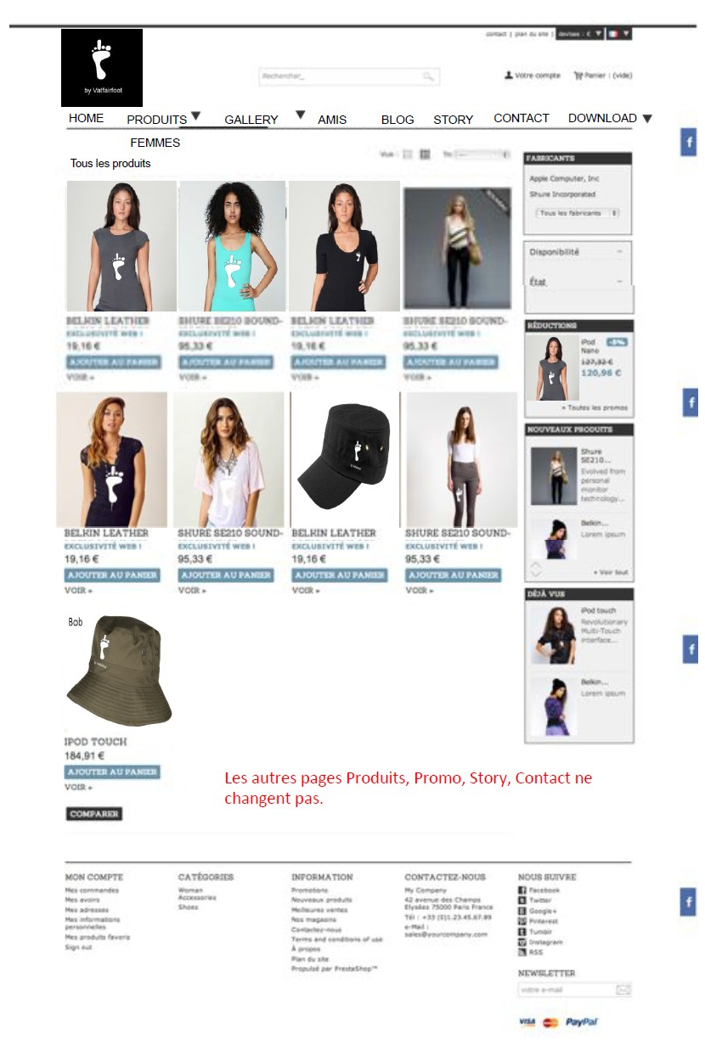

* 1. Fiche produits

Default product detail page of 01PREMIUM

* + 1. User Interface

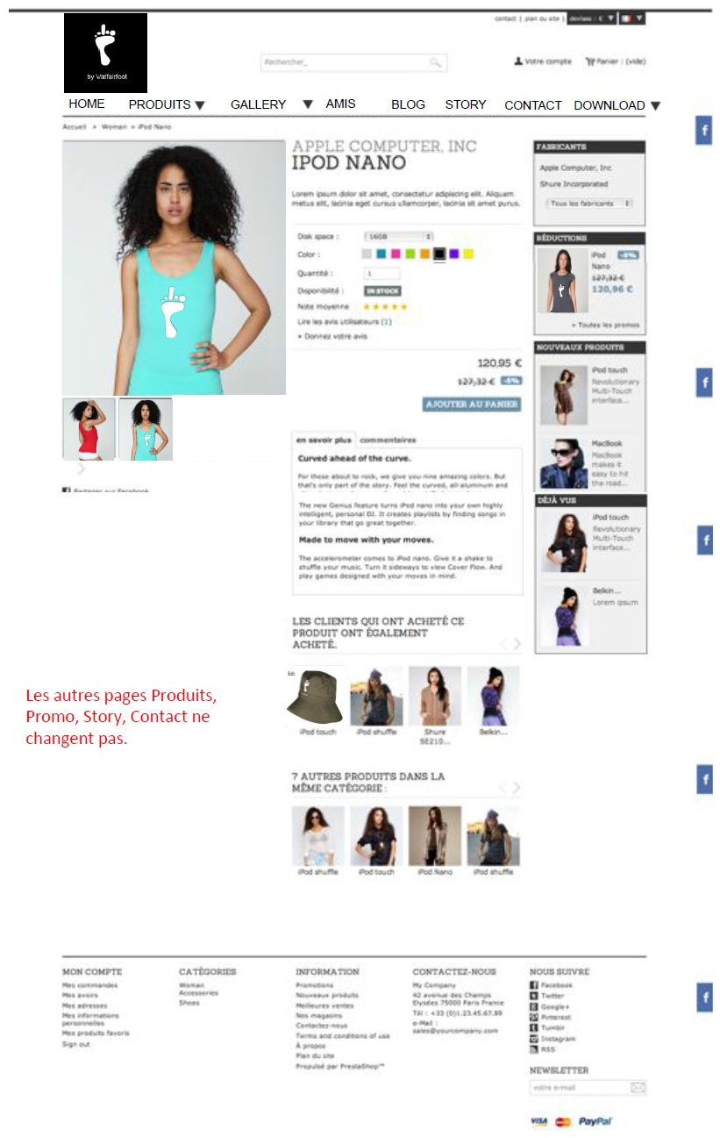

* 1. News

News detail page

* + 1. User Interface

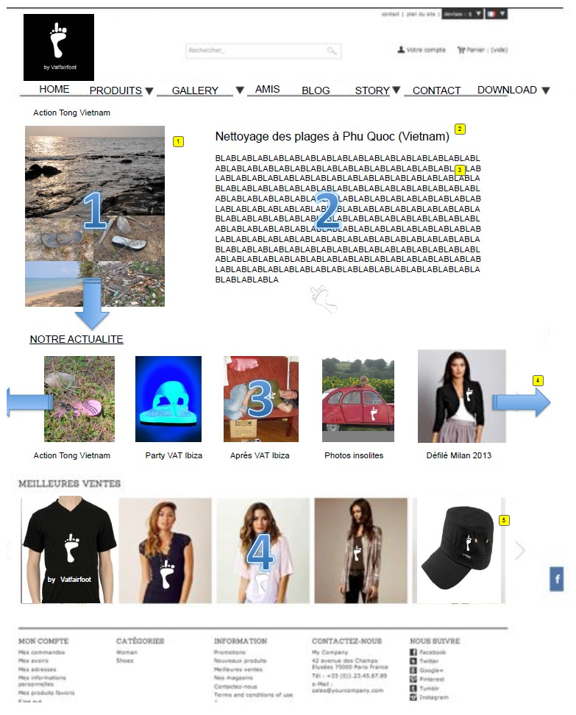

* + 1. Widget Table

|  |  |  |
| --- | --- | --- |
| Footnote | Label | Description |
| 1 | image or video | image or video. On click on image: open layer with image at the original size On click on video, play the video. |
| 2 | News title | News titles |
| 3 | News description | News description. WIZIWIG: free html. |
| 4 | News slider | Slider contains 5 photos visible (latest 5 news). slides if user clicks on the arrow. The slider contains max 20 news. The news on the slider is composed of 1 image and 1 title |
| 5 | Best sales slider | Slider contains 5 photos visible (5 best sales). slides if user click on the arrow. The slider contains max 20 best sales. The best sales on the slider is composed of 1 image and 1 title |

* 1. Gallery

Gallery

* 1. Photos

Gallery photos.

Gallery photo with

- images,

- rating star system,

- like (facebook)

**On rollover** on the photos: A text appears

**On click** on the photo, the photo open in a layer with:

- photo original size

- title

- description of the photo.

- button next, previous.

* + 1. User Interface

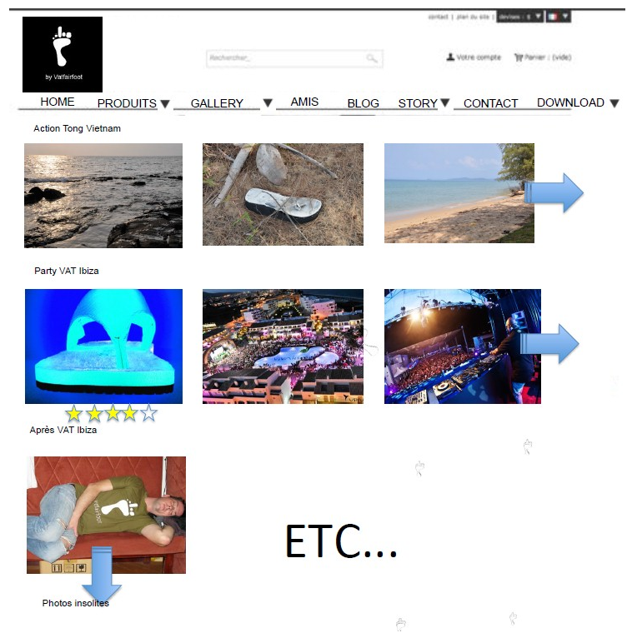

* 1. Videos

Gallery photos.

Gallery photo with

- images,

- rating star system,

- like (facebook)

**On rollover** on the videos: A text appears

**On click** on the videos, the photo open in a youtube layer with:

- video

- title

- description of the video.

* + 1. User Interface



* 1. Amis (friends)
     1. User Interface

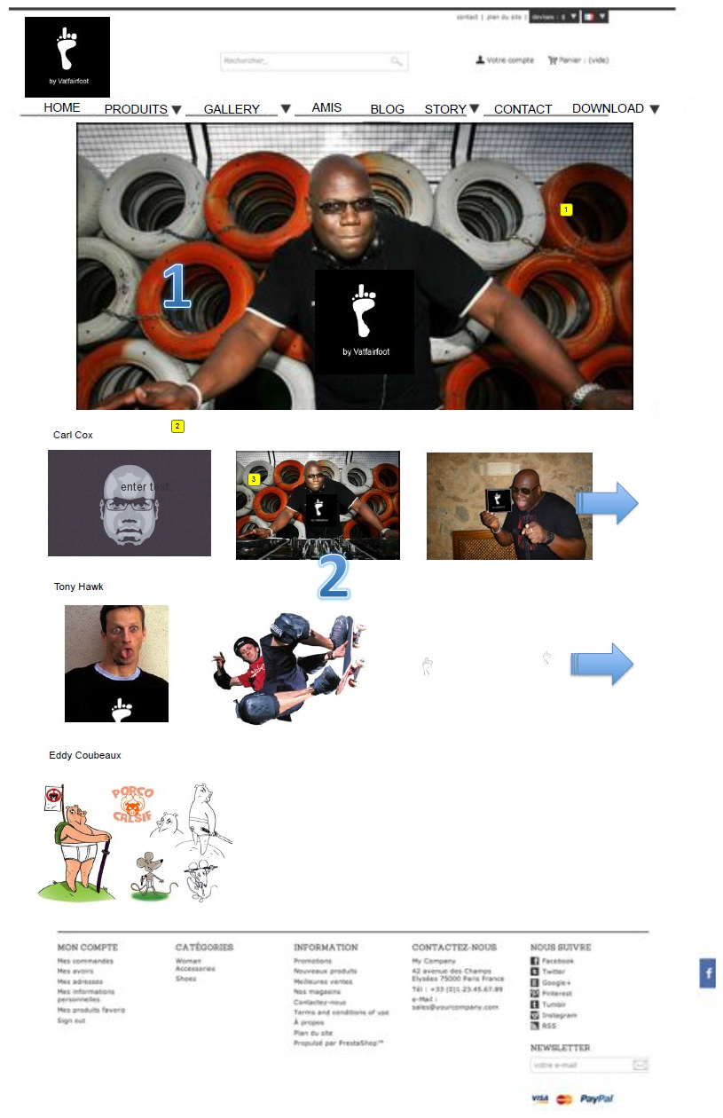

* + 1. Widget Table

|  |  |  |
| --- | --- | --- |
| Footnote | Label | Description |
| 1 | Main slider | Friends photo that slides every 5 secondes |
| 2 | Friend name | Friend name |
| 3 | Photo or video | Carl cox is a friend and we display 3 photos or videos. On click on arrow the photos slides and 3 other photos appears On rollover a text appears On click it opens the photo or video in a layer. possibility to have an external link to the friend's website, facebook... |

* 1. BLOG

We propose to use this blog module

**BLOG MODULE**

http://addons.prestashop.com/fr/content-management/2500-blog-prestablog-posts-categories-comments-products.html

* 1. STORY
  2. Notre histoire

Content page

* 1. Nos engagements

Content page

* 1. Nos actions

Content page

* 1. CONTACT

Contact page

Company address, telephone, fax etc..

Google map

* 1. DOWNLOAD

Page to download 3 type of pdf document

Simple content page with text and a link to download a pdf document.